Prospective title:
Germination niche dissimilarity (or not) in alpine plant communities
Prospective author list:
Espinosa del Alba, C., Fernández-Pascual, E., Götzenberger, L. & Jiménez-Alfaro, B.

- Research question
Test if there is germination niche dissimilarity or not in alpine plant communities
Do co-occurring species in the same communities have different germination strategies (i.e. niche dissimilarity)? Do these dissimilarities vary according to microclimatic gradients? Grubb hypothesis
Experimental design:
2 alpine study areas (one with Mediterranean climate the other with Temperate climate, see differences below).
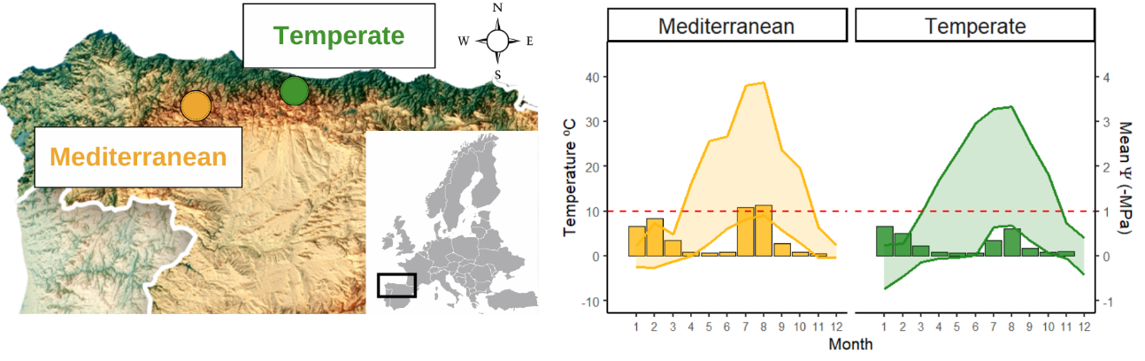
In each study area, we established four sites (at least 1 km apart) with a central representative plot where we did a floristic relevé and buried a Temperature and Water Potential datalogger. Then we additionally established 5 extra plots (1m²) in each cardinal direction (meaning 20 plots per site) where we also did floristic relevés and buried a temperature datalogger (see Mediterranean study area sites and plot distribution below). In total, 80 plots + 80 plots with temperature every 4h records data and community composition data
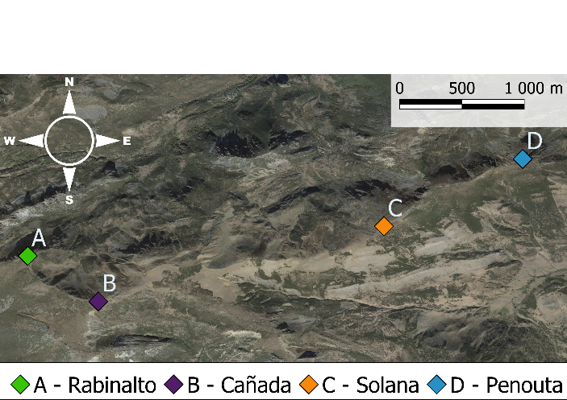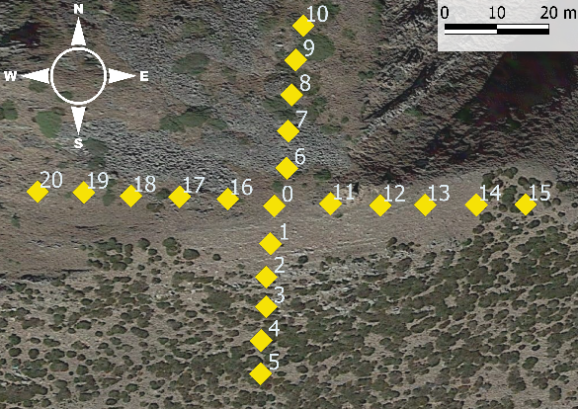

- Available data
We have 3 matrices x each study area (1) Species x plot, (2) Species x trait and (3) Community x environment
Species x plot:
Cover data that could be transformed to presence-absence.
Species x trait:
Species with germination driver traits data: 52 species. 4 germination treatments:
- Control (A): light (12h), alternating temperatures and water available
- Darkness (B): dark (24h), alternating temperatures and water available
- Water stress C): light (12h), alternating temperatures and water stress (Mpa -0.6)
- Constant temperature (D): light(12h), constant temperatures and water available
species |  | A_alternate_light | B_alternate_dark | C_alternate_WP | D_constant_light
Agrostis | tileni | 0.71 | 0.43 | 0.22 | 0.88
Armeria | duriaei | 0.07 | 0 | 0 | 0.6
Avenella | flexuosa | 0 | 0 | 0 | 0
Conopodium | majus | 0.01 | 0 | 0 | 0.07
Dianthus | langeanus | 0.75 | 0.7 | 0.56 | 0.73
Festuca | summilusitana | 0.06 | 0 | 0.02 | 0.07
Helictochloa | marginata | 0.06 | 0.1 | 0 | 0
Jasione | laevis | 0.4 | 0.28 | 0.18 | 0.32
Jurinea | humilis | 0.08 | 0.22 | 0.04 | 0.17
Luzula | caespitosa | 0.01 | 0 | 0 | 0
Minuartia | recurva | 0.56 | 0.65 | 0.12 | 0.67
Neoschischkinia | truncatula | 0.14 | 0 | 0.01 | 0.04
Phalacrocarpum | oppositifolium | 0 | 0 | 0 | 0
Phyteuma | hemisphaericum | 0.51 | 0.53 | 0.13 | 0.55

Here in each control que have the proportion of seeds germinated/initial number of seeds.
Seed mass and plant height (floral and vegetative) for all species (by the end of summer also leaf traits like SLA will be available). Preliminary exploration has shown that:
- In 61/80 plots (Mediterranean community) our species x trait data include the species that amount more than 80% of cover.
- In 48/80 plots (Temperate community) our species x trait data include the species that amount more than 80% cover.
*although this filter might not be necessary if we don’t weight the traits by abundance
Community x environment:
Elevation, aspect, 4h – temperature records.
- In the Mediterranean community environmental temperature data is available from July 2021 – May 2022 (4 loggers not recovered)
- In the Temperate community environmental temperature data is available from Oct 2018 - Aug 2019
Extra 16 plots for each community with hourly temperature and water potential data (2022-2024)
- Intended analytical approach
Community-level analysis using germination traits.
We first would start calculating community mean (or weighted) and functional diversity, but not sure about what specific indices would be more appropriate.
Our main doubts are considering how to handle germination traits. We have them calculated as proportions: number of seeds germinated/initial number of seeds. We aren’t sure if it would be best to use them as:
- raw seed numbers (i.e. (50 germinated 100 initial) like in a multinomial family
- as proportions (i.e. 0.5 following the above example)
- as odd ratios (each treatment odd ratio calculated with compared to control)
I will be following the explanation of the Trait-based ecology tools in R that you and other colleagues wrote to explore the species and community level analysis, but we would like your expertise and also your collaboration in the future manuscript.
- Questions for Lars
What specific indices would be more appropriate?
How to handle germination traits?
Note: if you have a Github profile we could add you to the repository so you could access the data and scripts.

